SENHIT and SAN MARINO RTV

San Marino, 8 March 2021
proudly presents
- ADRENALINA -

SENHIT will represent San Marino at Eurovision Song Contest 2021 with the song “ADRENALINA”!

She has collaborated with producers like Brian Higgins and Benny Benassi, performed all over the world from Los Angeles to London, Arena di Verona to Broadway. Her #FreakyTripToRotterdam project kept the Eurovision spirit alive in the darkest times and already obtained more than 5 million views on Youtube… People named her as Freaky Queen…
THIS IS SENHIT. ONE OF THE MOST INTERNATIONAL ITALIAN ARTISTS!

Senhit will represent San Marino (RTV) at the Eurovision Song Contest 2021 to be held in Rotterdam. On stage she will bring a special version of the single "ADRENALINA", whose video with the artistic direction of worldwide known LUCA TOMMASSINI, is available from Monday 8 March on the YouTube Channel of Eurovision.

Meanwhile Senhit launched herself from a plane to announce her Eurovision 2021 entry, opening a parachute with the song title ADRENALINA, with which she hovered between Bologna and San Marino. With that action, the artist definitively certifies herself as the "Freaky Queen”!

- I always want adventure, excitement, new experiences, to live at 360 degrees. “Adrenalina” represents me best with it’s mix of international electro pop and refined sounds of instruments that come from Eritrea! That’s why I’ve decided to take it also on the Eurovision stage. With Luca Tommassini we are preparing the greatest show! - SENHIT

San Marino, 8 March 2021

"ADRENALINA" has an international style in which electro pop, Latin sounds and also special instruments come from Eritrea, the land of origin of Senhit, namely the keberö (drum) and the krar (guitar). The gritty voice of Senhit moves on the refined harmonic structures, the refrain remains in the head and an engaging rhythm increases... the ADRENALINA!

The international team behind “Adrenalina”:
Lyrics: Thomas Stengaard, Joy Deb, Linnea Deb, Jimmy Thörnfeldt, Kenny Silverdique, Suzi Pancenkov, Malou Linn Eloise Ruotsalainen, Chanel Tukia, Senhit, Dillard Tramar
Music: Thomas Stengaard, Joy Deb, Linnea Deb, Jimmy Thörnfeldt, Kenny Silverdique, Suzi Pancenkov ,Malou Linn Eloise Ruotsalainen, Chanel Tukia, Senhit, Dillard Trama

San Marino RTV’s delegation is led for the twelfth year by the experience of the Head of Delegation Alessandro Capicchioni, the top-level artistic staff is led by the eclectic creative director Luca Tommassini. -END-

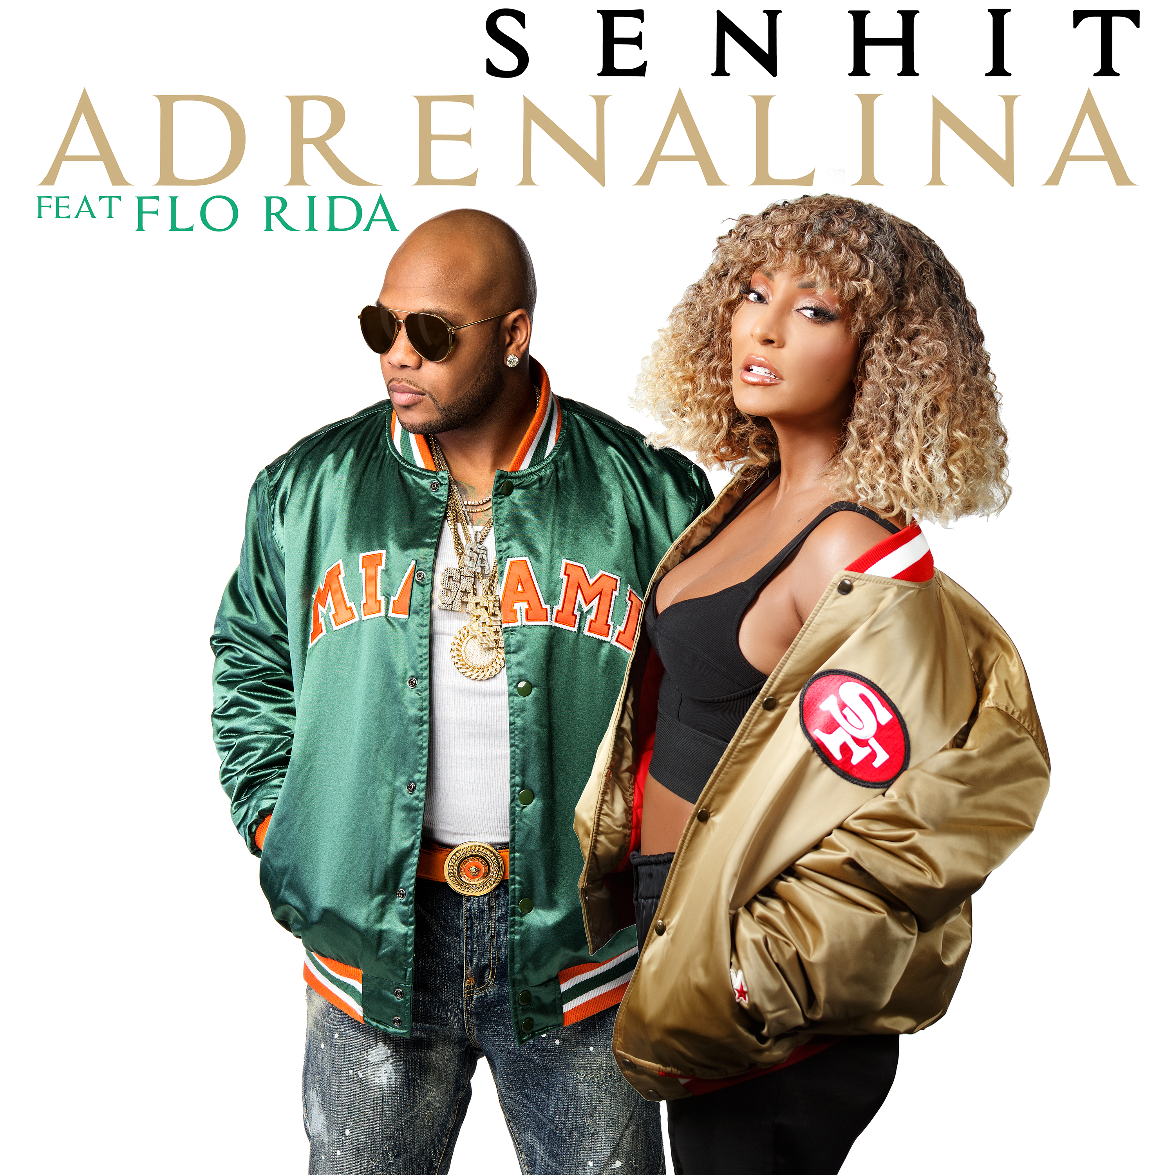
SENHIT ft. FLO RIDA
- ADRENALINA -

AVAILABLE ON ALL MUSIC STREAMING PLATFORMS

FROM

12 MARCH 2021

On 12 March the big news arrives!

“ADRENALINA”, the new single from SENHIT feat. FLO RIDA, in which the voice of the Italian Eritrean singer joins the bars of the multi-platinum rapper, in a song that promises to be a real hit!

After revealing the Eurovision Version of her new single “ADRENALINA”, Senhit will release an original extended version the song with the well known global rapper
Flo Rida! The duo uniting their powers to let not only Europe and Australia, but the whole world dance with the energetic rhythms. The song will be released on 12 of March on all music streaming services and with a music video on the YouTube channel of Senhit.

San Marino, 8 March 2021
FLO RIDA is an American rapper, singer and songwriter from Carol City, Florida. His 2007 breakout single "Low" was number one for 10 weeks in the United States and broke the record for digital download sales at the time of its release. Flo Rida has sold over 100 million records worldwide, making him one of the best-selling music artists. His catalog includes the international hit singles "Right Round", "Club Can't Handle Me", "Good Feeling", "Wild Ones", "Whistle", "I Cry", "G.D.F.R." and "My House".

Head of Press: Ersin Parlak - ersin@ersinparlak.com - +393478739866
Italian Press Office: Parole & Dintorni (Marta Falcon – marta@paroleedintorni.it – 02 20404727)
Head of Delegation San Marino RTV: Alessandro Capicchioni - capicchioni@sanmarinortv.sm
Management: Roberto Mancinelli (roberto.mancinelli@imeanmusic.com), IMEAN Music Publishing & Management

www.senhit.com - Facebook - Twitter
Instagram - YouTube

